## Working Title - AMIGO

An integrated system for students at IIIT Delhi

THIS PAGE IS JUST FOR DIAGRAMS, WHOEVER WANTS TO WRITE SOMETHING, START FROM NEXT PAGE.

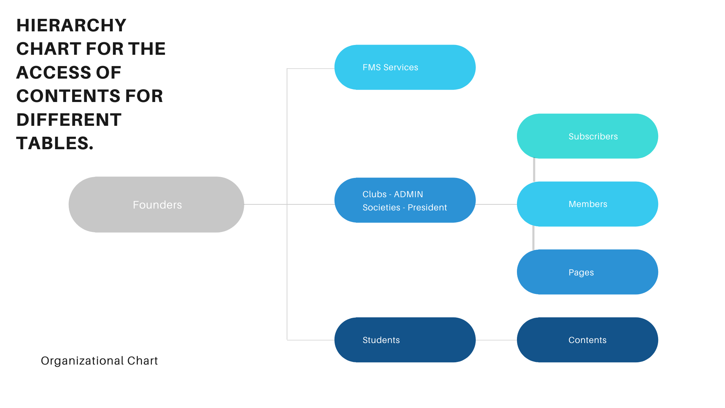

JASMINE - WE NEED TO START A STARTUP, need to generate revenue, keep a check on that. For this purpose you can propose something like, we can contact udacity, Coursera, udemy, etc to give ads on our platform. It is a completely student-centric platform, best suited for them. They are one of the stakeholders.

The second stakeholder can be companies that can conduct various hackathons on our platform and offer internships to students. They are going to pay us for hackathons, many startups will be interested in that.

Third stakeholders can be YouTubers, bloggers if they want to advertise.

Fourth can be the book publishers etc. Think about it. Or we can make slots for google ads on our website

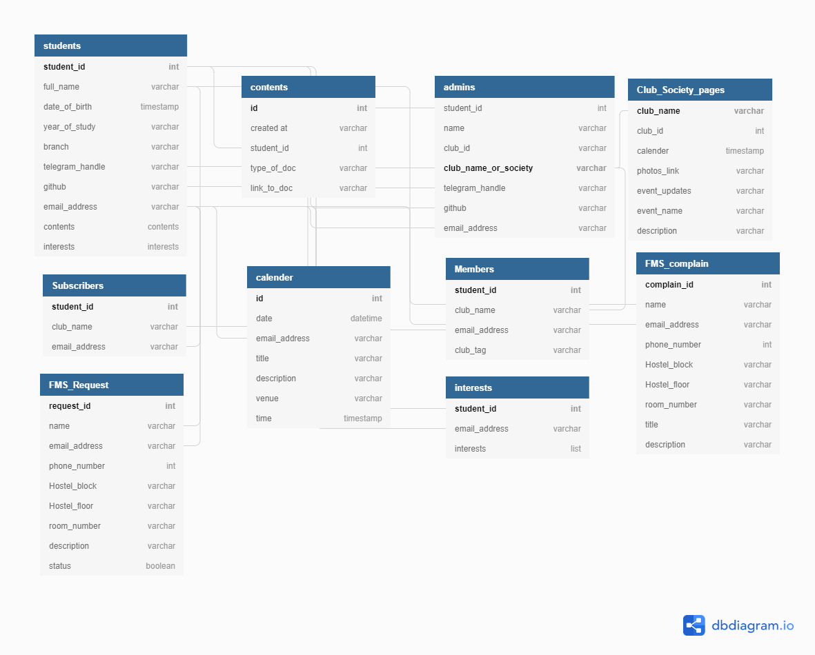

|  |  |  |  |
| --- | --- | --- | --- |
| Students | | | |
| SNo. | Attribute | Domain | Description |
| 1. | student_id | int | The unique student id (Ex. 2019219 etc.) |
| 2. | full_name | varchar | The full name of the student (Ex. Aditya Garg etc.) |
| 3. | date_of_birth | timestamp | The date of birth of the person (05:1:2018 etc.) |
| 4. | year_of_study | int | Year of enrollment of student (Ex.2018, 2019, etc) |
| 5. | branch | varchar | The branch of the student (Ex. CSE, ECE, etc) |
| 6. | telegram_handle | varchar | The handle belonging to telegram |
| 7. | github | varchar | Github user handle of the person |
| 8. | email_address | varchar | The email address of the user (Ex. [abc@gmail.com](mailto:abc@gmail.com) etc) |
| 9. | contents | varchar | Materials the person has uploaded to his profile |
| 10. | interest | varchar | Technical Interest of the person (Ex. Gaming, Programming, etc.) |

|  |  |  |  |
| --- | --- | --- | --- |
| Subscribers | | | |
| SNo. | Attribute | Domain | Description |
| 1. | student_id | int | The unique student id (Ex. 2019219 etc.) |
| 2. | club_name | varchar | The name of the club subscribed |
| 3. | email_address | varchar | The email address of the user (Ex. [abc@gmail.com](mailto:abc@gmail.com) etc) |

|  |  |  |  |
| --- | --- | --- | --- |
| FMS_Request | | | |
| SNo. | Attribute | Domain | Description |
| 1. | request_id | varchar | The request-id |
| 2. | full_name | varchar | The full name of the student (Ex. Aditya Garg etc.) |
| 3. | email_address | varchar | The email address of the user (Ex. [abc@gmail.com](mailto:abc@gmail.com) etc) |
| 4. | phone_number | int | The phone no of the person requesting |
| 5. | Hostel_block | varchar | The hostel name (Ex. Old boys, Girls hostel, etc) |
| 6. | Hostel_floor | varchar | The floor no (Ex. A1,B3, etc) |
| 7. | Hostel_room | varchar | The hostel room number of the person making the request(Ex. A107, C008, etc.) |

|  |  |  |  |
| --- | --- | --- | --- |
| Contents | | | |
| SNo. | Attribute | Domain | Description |
| 1. | id | int | The id for the content uploaded |
| 2. | created_at | varchar | The date of the upload |
| 3. | student_id | int | The unique student id (Ex. 2019219 etc.) |
| 4. | type_of_doc | varchar | The type of the doc uploaded (Ex. Notes, Book, etc) |
| 5. | link_of_doc | varchar | The link to the particular doc. |

|  |  |  |  |
| --- | --- | --- | --- |
| Calendar | | | |
| SNo. | Attribute | Domain | Description |
| 1. | id | int | The unique id of the event |
| 2. | date | datetime | The date of the event in the calendar |
| 3. | email_address | varchar | Email address of the user (Ex. [abc@gmail.com](mailto:abc@gmail.com) etc) |
| 4. | title | varchar | The title of the event (Ex. Prosort, hackathon, etc) |
| 5. | description | varchar | The description of the event |
| 6. | venue | varchar | The venue of the event (Ex. C101,C102, etc) |
| 7. | time | timestamp | The time of the event |

|  |  |  |  |
| --- | --- | --- | --- |
| Admins | | | |
| SNo. | Attribute | Domain | Description |
| 1. | student_id | int | The unique student id (Ex. 2019219 etc.) |
| 2. | full_name | varchar | The full name of the student (Ex. Aditya Garg etc.) |
| 3. | club_id | varchar | The unique club id the admin maintains |
| 4. | club_name | varchar | The name of the club the admin maintains(Ex. Foobar) |
| 5. | telegram_handle | varchar | The admin telegram handle |
| 6. | github | varchar | The admin GitHub repository link |
| 7. | email_address | varchar | The email address of the admin (Ex. [abc@gmail.com](mailto:abc@gmail.com) etc) |

|  |  |  |  |
| --- | --- | --- | --- |
| Members | | | |
| SNo. | Attribute | Domain | Description |
| 1. | student_id | int | The unique student id (Ex. 2019219 etc.) |
| 2. | club_name | varchar | The name of the club the member belongs(Ex. Foobar) |
| 3. | email_address | varchar | The email address of the member (Ex. [abc@gmail.com](mailto:abc@gmail.com) etc) |
| 4. | club_tag | varchar | The tag obtained from the club admin. |

|  |  |  |  |
| --- | --- | --- | --- |
| Interests | | | |
| SNo. | Attribute | Domain | Description |
| 1. | student_id | int | The unique student id (Ex. 2019219 etc.) |
| 2. | email_address | varchar | The email address of the user (Ex. [abc@gmail.com](mailto:abc@gmail.com) etc) |
| 3. | interests | varchar | The interests of the student (Ex. Gaming, Programming etc.) |

|  |  |  |  |
| --- | --- | --- | --- |
| Club_society_pages | | | |
| SNo. | Attribute | Domain | Description |
| 1. | club_name | varchar | The name of the club the page belongs(Ex. Foobar) |
| 2. | club_id | int | The unique id of the club page |
| 3. | calendar | timestamp | The personal calendar of the page |
| 4. | photos _link | varchar | The links of photos the page has. |
| 5. | event_updates | varchar | The event updated on the page |
| 6. | event_name | varchar | The name of the event added by the page |
| 7. | description | varchar | The description of the page |

|  |  |  |  |
| --- | --- | --- | --- |
| Fms_Complaint | | | |
| SNo. | Attribute | Domain | Description |
| 1. | complaint_id | int | The unique id of the complaint generated |
| 2. | name | varchar | The name of the student who makes the complaint |
| 3. | email_address | varchar | The email address of the person (Ex. [abc@gmail.com](mailto:abc@gmail.com) etc) |
| 4. | phone_number | int | The phone number of the person making the complaint |
| 5. | Hostel_block | varchar | The hostel name (Ex.Old boys, Girls hostel, etc) |
| 6. | Hostel_floor | varchar | The floor no of the person making the complaint(Ex. A1, B3 etc) |
| 7. | Hostel_room | varchar | The hostel room number of the person making the complaint |
| 8. | title | varchar | The title of the complaint |
| 9. | description | varchar | The description of the complaint |

**Clubs/Committee Pages**

Our System will provide a very effective yet simple way for clubs/council to reach other students, via announcements, calender or interact with the club representatives directly. These are some of the areas where we will be helping.

**Reaching new students?**

=>Clubs can reach new students via there page and accumulate followers.

Data Entities - Club_Society_Pages, Students, subscribers

**Making Announcements?**

=>Clubs can make announcements on their page which will reach their followers via a notification

Data Entities - Club_Society_pages, Members, calendar, students

**Organizing Events?**

=>Clubs can easily organize events and collect volunteers as per there requirements if needed by looking at the interests/expertise of an individual on his/her account or just roll out a form via announcements.

Data Entities - Club_Society_pages, Students, Members,Subscribers

**Increasing Student Interaction?**

= >students can directly interact with the club admins/members as a badge will appear on an account if they are part of any club or hold any position of responsibility.

Data Entities - Club_Society_pages, Students, Subscribers

**Organized common calendar?**

=>Our application will offer an organized calendar that the clubs can edit and add events on it. They can also be able to add event-related information such as description, time, venue of a event which will also trigger a notification for the followers. This calendar will be available to all the students by displaying all the events from all the clubs.

Data Entities - Club_Society_pages, Calender, Students.

We will be having different pages for clubs and council each handled by there respective admins.

1. Only the admin has permission to post or edit the content on the page.
2. Members can only be added or removed by the admin of that particular club.
3. For every post made or event added to the calendar, a notification will be sent to the followers of that particular page regarding the same.

Each page has there own database which can be edited by only the respective presidents

**Subscribers**

**Interested in a club? Need not to worry, we got it covered it for YOU..**

Now you can get all the updates of your favorite club by just subscribing to their pages. The subscribers get daily/weekly updates from the pages they have subscribed to their message box.

**Want updates on your favorite club events?**

=>Just press the bell icon for a specific page and never miss any updates from your favorite club. Get notification of all the updates and stay up to date.

Data Entities - Club_Society_pages, Subscribers.

**Students**

The heart of our project is Student’s and we have got something special for them. The students can make their personal profiles listing their information such as name, email, telegram_link, etc. Not only this the students can upload their personal stuff such as notes, books, online resources, etc. along with the other users. The students can subscribe to club_pages to receive updates from them. The students can even make request and complain to FMS directly from our platform.

**Need updates?**

Get to know what interesting work your fellow mates are upto by checking their feeds.

**Want help?**

Just ping your seniors and ask all your doubts. Find the best senior for your problem by looking at their skillset/interests.

**Willing to help?**

There are surely a lot of students out there who need your guidance when they are stuck at something. Be their helping hand by sharing your experiences.

**Want to share your resources to others?**

The students can now share resources/contents such as Notes, online resources under specified categories directly to others by uploading it on their personal profiles. The other students can then view them or download them from their profiles. The students can even sort the resources by topics such as Advanced Programming, Ada etc. and it sorts according to their rating (we have devised a way to rate them).

**Increases Interaction among the students?**

The students can interact with other students through resource sharing and taking guidance from others regarding a common topic thus increasing the interaction among fellow students.

**Helps with academics?**Sharing resources and taking guidance from others helps people perform well in academics as well.

**Member of some exclusive club?**

We won’t stop you from bragging your achievements and memberships. There is a special tag for each club member that would make your profile noteworthy.

FMS Facilities-

Do you want to make a complaint/request to the FMS and fed up of the whatsapp system and waiting for reply. Our platform takes care of that as well. The students can file a complaint against some problems handled by the Fms. Not only this the students can now request a service such as cleaning, ac service from the Fms directly through our platform.

**Want to file a complaint?**

The students can file a complaint anonymously directly from our platform so that the Fms can start to improve it as soon as possible.

**The Fms does not respond to the Whatsapp message?**

The students now need not to apply for the request such as cleaning etc on whatsapp. They can directly request from our site. And we make sure the Fms responds to request as soon as possible. Making the process a lot easier.

**Get regular updates from Fms as well?**

The Fms can send you updates such as fire drills, watercooler cleaning, Net-speed down etc. to the students directly through our platform. Reduces those unnecessary emails for this from the hostel department.